**Master Functional Document**

|  |  |
| --- | --- |
| **Application** | NGERP - Centra |
| **Service Bundle** | Master Management |
| **Service Request** | Sales Region Mapping |

**Description :**

The address for the business partner is created in sales region mapping master. It is mapped in the location tab in manage partner maaster.

**Workflow Process :**

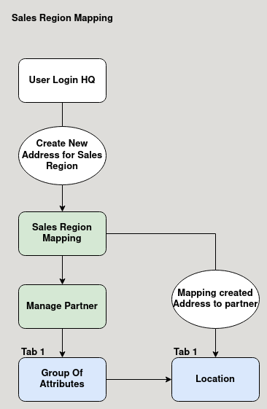

**Business Rules :**

* User Should login as HQ to create new sales region mapping.
* Sales region mapping is not editable in region.
* The created address is mapped to the business partner in manage partner location tab.
* The address for the partner will load from the sales region mapping master.